University of Central Missouri

Department of Computer Science & Cybersecurity

CS5710 Machine Learning

Fall 2025

Home Assignment 2.

Student name: Vaishnavi Beesa

Submission Requirements:
- Once finished your assignment push your source code to your repo (GitHub) and explain the work through the ReadMe file properly. Make sure you add your student info in the ReadMe file.
- Comment your code appropriately IMPORTANT.
- Any submission after provided deadline is considered as a late submission.

Part A — Calculations (answers with steps)
Q1. Decision Stump Prediction
Stump: h(x) = + if Sneezing = Yes, otherwise -.
Dataset (4 examples):
- (Yes, Label = +) → h = + → correct
- (No, Label = -) → h = - → correct
- (Yes, Label = -) → h = + → wrong
- (No, Label = -) → h = - → correct
- Training error rate = (# wrong) / (total) = 1 / 4 = 0.25 = 25%.
  - Step-by-step: wrong = 1; total = 4; 1 ÷ 4 = 0.25.
- Compare to memorizer: a memorizer that predicts perfectly has 0% training error. So the stump (25%) is worse than the memorizer (0%).

Q2. Training Error as Splitting Criterion
Data (6 records):
# | Age (x1) | Exercise (x2) | Diet (x3) | Label
1 | Young | High | Poor | Yes
2 | Young | Medium | Good | Yes
3 | Mid | Low | Poor | No
4 | Old | Medium | Poor | No
5 | Old | High | Good | Yes
6 | Mid | Low | Poor | No
Count of labels: Yes = rows 1,2,5 = 3; No = rows 3,4,6 = 3.
We compute training-error if we split on each feature and at each child predict the majority label.
Split on Age (x1)
- Young: rows 1 & 2 → labels {Yes, Yes} → majority = Yes → errors = 0.
- Mid: rows 3 & 6 → {No, No} → majority = No → errors = 0.
- Old: rows 4 & 5 → {No, Yes} → tie; any majority choice gives 1 error (min possible = 1).
- Total errors = 1 → error rate = 1 / 6 = 0.1667 = 16.67%.
Split on Exercise (x2)
- High: rows 1 & 5 → {Yes, Yes} → errors = 0.
- Medium: rows 2 & 4 → {Yes, No} → tie → errors = 1.
- Low: rows 3 & 6 → {No, No} → errors = 0.
- Total errors = 1 → error rate = 1/6 = 16.67%.
Split on Diet (x3)
- Good: rows 2 & 5 → {Yes, Yes} → errors = 0.
- Poor: rows 1, 3, 4, 6 → {Yes, No, No, No} → majority = No (3 No vs 1 Yes) → errors = 1 (row 1).
- Total errors = 1 → error rate = 1/6 = 16.67%.
Answer (2.1): All three features give the same training error rate 1/6 ≈ 16.67%.
Answer (2.2): Since all tie, any of x1, x2, or x3 could be chosen as best root split by training-error criterion.

Q3. Entropy & Information Gain (same dataset)
We previously found Yes = 3, No = 3, total n = 6.
3.1 Entropy of labels
Entropy H(Y)=−∑p(y)log⁡2p(y)H(Y) = -\sum p(y) \log_2 p(y).
- p(Yes)=3/6=0.5p(Yes) = 3/6 = 0.5.
- p(No)=3/6=0.5p(No) = 3/6 = 0.5.
So H(Y)=−0.5log⁡2(0.5)−0.5log⁡2(0.5)H(Y) = -0.5\log_2(0.5) - 0.5\log_2(0.5).
log⁡2(0.5)=−1\log_2(0.5) = -1, so:
H(Y)=−0.5(−1)−0.5(−1)=0.5+0.5=1H(Y) = -0.5(-1) - 0.5(-1) = 0.5 + 0.5 = 1.
Entropy = 1.0 bit.
3.2 Entropy after splitting on Exercise (x2)
Exercise values and child node entropies:
- High (2 samples): labels {Yes, Yes} → class distribution: (1.0, 0.0) → Entropy = 0
- Medium (2 samples): labels {Yes, No} → distribution (0.5,0.5) → Entropy = 1
- Low (2 samples): labels {No, No} → distribution (0,1.0) → Entropy = 0
Weighted entropy:
H(Y∣x2)=26⋅0+26⋅1+26⋅0=26=13≈0.3333H(Y|x2) = \frac{2}{6}\cdot0 + \frac{2}{6}\cdot1 + \frac{2}{6}\cdot0 = \frac{2}{6} = \frac{1}{3} \approx 0.3333
Entropy after split ≈ 0.3333 bits.
3.3 Information gain
IG=H(Y)−H(Y∣x2)=1.0−13=23≈0.6667 bits.IG = H(Y) - H(Y|x2) = 1.0 - \frac{1}{3} = \frac{2}{3} \approx 0.6667 \text{ bits.}
3.4 Is Exercise a good split?
Yes. An information gain of ~0.667 bits (out of maximum 1 bit) is substantial — Exercise meaningfully reduces label uncertainty. So Exercise is a good split.

Q4. Confusion Matrix Metrics
Confusion matrix (100 samples):
 | Predicted + | Predicted -
Actual + | 25 (TP) | 5 (FN)
Actual - | 15 (FP) | 55 (TN)
Compute metrics:
- Accuracy = (TP + TN) / total
= (25 + 55) / 100 = 80 / 100 = 0.80 = 80%.
- Precision = TP / (TP + FP)
= 25 / (25 + 15) = 25 / 40 = 0.625 = 62.5%.
- Recall (Sensitivity, TPR) = TP / (TP + FN)
= 25 / (25 + 5) = 25 / 30 = 0.8333 = 83.33%.
- Specificity (TNR) = TN / (TN + FP)
= 55 / (55 + 15) = 55 / 70 ≈ 0.7857 = 78.57%.
- F1-score = 2⋅Precision⋅RecallPrecision+Recall2 \cdot \dfrac{\text{Precision}\cdot\text{Recall}}{\text{Precision}+\text{Recall}}
Precision = 0.625, Recall = 0.833333...
Numerator = 2⋅0.625⋅0.833333=1.04166672 \cdot 0.625 \cdot 0.833333 = 1.0416667.
Denominator = 0.625+0.833333=1.45833330.625 + 0.833333 = 1.4583333.
F1 = 1.0416667 / 1.4583333 ≈ 0.7142857 = 71.43%.
4.2 If dataset were imbalanced (80 negatives, 20 positives)
When classes are imbalanced, accuracy can be misleading (a classifier that predicts always negative would get 80% accuracy). The most informative metrics are Precision and Recall (and their harmonic mean, F1-score) because they focus on the positive class performance.
- Use Recall if missing positives is costly (you want to catch as many positives as possible).
- Use Precision if false positives are costly.
- F1-score is a single-number compromise summarizing both.

Q5. Distance Calculations (kNN)
Points:
- A = (2,4), Red
- B = (4,4), Blue
- C = (4,6), Red
New point P = (5,4).
5.1 Euclidean distances
Euclidean distance formula d((x1,y1),(x2,y2))=(x1−x2)2+(y1−y2)2d((x_1,y_1),(x_2,y_2))=\sqrt{(x_1-x_2)^2+(y_1-y_2)^2}.
- d(P,A)=(5−2)2+(4−4)2=32+02=9=3.0.d(P,A) = \sqrt{(5-2)^2 + (4-4)^2} = \sqrt{3^2 + 0^2} = \sqrt{9} = 3.0.
- d(P,B)=(5−4)2+(4−4)2=1+0=1.0.d(P,B) = \sqrt{(5-4)^2 + (4-4)^2} = \sqrt{1 + 0} = 1.0.
- d(P,C)=(5−4)2+(4−6)2=1+(−2)2=1+4=5≈2.23607.d(P,C) = \sqrt{(5-4)^2 + (4-6)^2} = \sqrt{1 + (-2)^2} = \sqrt{1+4} = \sqrt{5} \approx 2.23607.
5.2 1-NN prediction
Nearest neighbor is B (distance 1.0) which is Blue → predict Blue.
5.3 3-NN prediction (majority vote)
Nearest 3: B (Blue), C (Red), A (Red) → votes: Red = 2, Blue = 1 → predict Red.

Q6. K-fold Cross-Validation
Given 4-fold CV errors:
Fold | k=1 | k=3 | k=5
1 | 0.20 | 0.15 | 0.10
2 | 0.25 | 0.20 | 0.15
3 | 0.15 | 0.10 | 0.10
4 | 0.30 | 0.20 | 0.20
6.1 Mean CV error for each k
Compute means (sum errors across folds ÷ 4):
- k = 1: mean = (0.20 + 0.25 + 0.15 + 0.30) / 4 = 0.90 / 4 = 0.225.
- k = 3: mean = (0.15 + 0.20 + 0.10 + 0.20) / 4 = 0.65 / 4 = 0.1625.
- k = 5: mean = (0.10 + 0.15 + 0.10 + 0.20) / 4 = 0.55 / 4 = 0.1375.
6.2 Which k generalizes best?
Lower mean CV error = better generalization estimate. k = 5 has the lowest mean error 0.1375, so k = 5 generalizes best among these options.

Part B — Programming (code, instructions, and guidance)
Below are ready-to-run Python scripts (with comments) for Q7–Q9. Put these scripts into your GitHub repo, add a clear README.md (explain dataset, dependencies, how to run), and comment code heavily as required by the assignment.
You can run them in any standard Python environment with scikit-learn, matplotlib, numpy, and pandas installed.

Environment / Dependencies
Install (example):
pip install numpy pandas scikit-learn matplotlib seaborn
(Seaborn only used optionally for nicer plotting; core tasks use matplotlib & sklearn.)

Q7 — Decision Tree on Iris (sklearn)

"""
Q7: Train DecisionTreeClassifier on Iris with max_depth=1,2,3 and report train/test accuracy.
Run: python q7_decision_tree.py
"""

import numpy as np
from sklearn.datasets import load_iris
from sklearn.model_selection import train_test_split
from sklearn.tree import DecisionTreeClassifier
from sklearn.metrics import accuracy_score

# Load Iris
data = load_iris()
X = data.data # 4 features
y = data.target # 3 classes

# Train/test split (stratified)
X_train, X_test, y_train, y_test = train_test_split(
X, y, test_size=0.3, random_state=42, stratify=y)

depths = [1, 2, 3]
results = []

for d in depths:
clf = DecisionTreeClassifier(max_depth=d, random_state=42)
clf.fit(X_train, y_train)
y_train_pred = clf.predict(X_train)
y_test_pred = clf.predict(X_test)
train_acc = accuracy_score(y_train, y_train_pred)
test_acc = accuracy_score(y_test, y_test_pred)
results.append((d, train_acc, test_acc))
print(f"max_depth={d} | train_acc={train_acc:.4f} | test_acc={test_acc:.4f}")

s
# Discussion guidance:
# - If train_acc and test_acc both low -> underfitting (too simple)
# - If train_acc >> test_acc -> overfitting
# - If both high and close -> good generalization

# output:
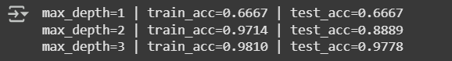

# Discussion guidance:
# - If train_acc and test_acc both low -> underfitting (too simple)
# - If train_acc >> test_acc -> overfitting
# - If both high and close -> good generalization
What to report:
- For each max_depth, print training and test accuracy (as shown).
- Discuss signs:
  - max_depth=1 likely underfits (low train & test accuracy).
  - max_depth=2 or 3 often improves training accuracy; if training accuracy climbs to ~1.0 while test accuracy drops, that indicates overfitting. If both train/test high and similar → good fit.

Q8 — kNN classification and decision boundaries (Iris, 2 features)
Q8: kNN decision boundaries using only 2 features: sepal length & sepal width.
import numpy as np
import matplotlib.pyplot as plt
from sklearn.datasets import load_iris
from sklearn.neighbors import KNeighborsClassifier
from sklearn.model_selection import train_test_split
from matplotlib.colors import ListedColormap

# Load Iris and select first two features
data = load_iris()
X = data.data[:, :2] # sepal length, sepal width
y = data.target

# Train/test split (optional; we'll fit on entire data to show boundary)
X_train, X_test, y_train, y_test = train_test_split(
X, y, test_size=0.2, random_state=42, stratify=y)

ks = [1, 3, 5, 10]

h = .02 # step size in the mesh

# Create color maps
cmap_light = ListedColormap(['#FFAAAA', '#AAFFAA', '#AAAAFF'])
cmap_bold = ListedColormap(['#FF0000', '#00FF00', '#0000FF'])

for i, k in enumerate(ks):
clf = KNeighborsClassifier(n_neighbors=k)
clf.fit(X_train, y_train)

# Create meshgrid
x_min, x_max = X[:, 0].min() - 1, X[:, 0].max() + 1
y_min, y_max = X[:, 1].min() - 1, X[:, 1].max() + 1
xx, yy = np.meshgrid(np.arange(x_min, x_max, h),
np.arange(y_min, y_max, h))
Z = clf.predict(np.c_[xx.ravel(), yy.ravel()])

Z = Z.reshape(xx.shape)
plt.figure(figsize=(6, 4))
plt.contourf(xx, yy, Z, cmap=cmap_light, alpha=0.6)
plt.scatter(X_train[:, 0], X_train[:, 1], c=y_train, cmap=cmap_bold,
edgecolor='k', s=50, label='train')
plt.scatter(X_test[:, 0], X_test[:, 1], c=y_test, cmap=cmap_bold,
marker='x', s=60, label='test')
plt.title(f"k-NN (k={k}) — sepal length vs sepal width")
plt.xlabel("Sepal length (cm)")
plt.ylabel("Sepal width (cm)")
plt.legend()
plt.tight_layout()
plt.show()

# Comments to write in report:
# - k=1: decision boundary will be very jagged (high variance), small regions around points.
# - As k increases, boundaries smooth out (less variance, more bias).
# - Very large k may over-smooth and cause underfitting (too coarse).

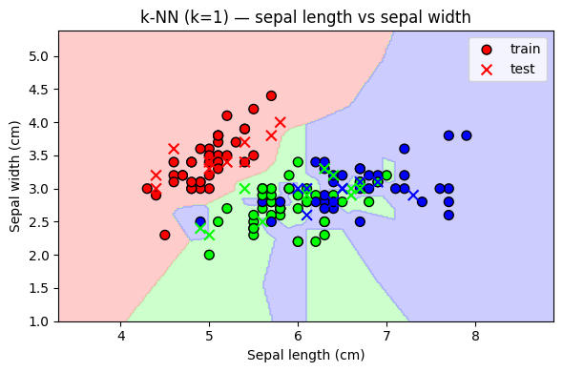
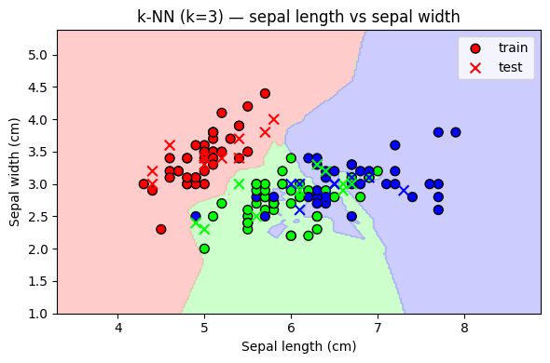
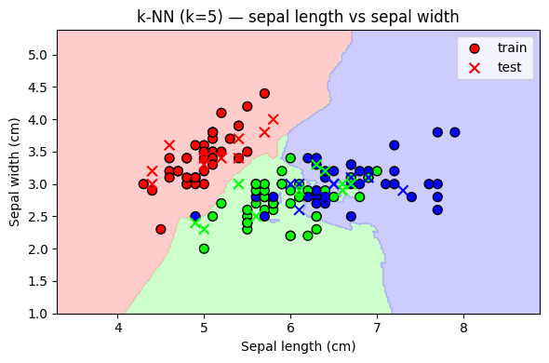
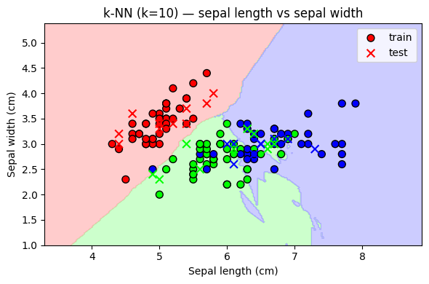

Q9 — Performance Evaluation (kNN k=5)
import numpy as np
import matplotlib.pyplot as plt
from sklearn.datasets import load_iris
from sklearn.neighbors import KNeighborsClassifier
from sklearn.model_selection import train_test_split
from sklearn.metrics import confusion_matrix, classification_report, roc_curve, auc
from sklearn.preprocessing import label_binarize
from itertools import cycle

# Load Iris
data = load_iris()
X = data.data
y = data.target
n_classes = len(np.unique(y))

# Train/test split
X_train, X_test, y_train, y_test = train_test_split(
X, y, test_size=0.3, random_state=42, stratify=y)

# Train kNN
k = 5
clf = KNeighborsClassifier(n_neighbors=k)
clf.fit(X_train, y_train)
y_pred = clf.predict(X_test)

# Confusion matrix
cm = confusion_matrix(y_test, y_pred)
print("Confusion Matrix:")
print(cm)

# Classification report
print("\nClassification Report:")
print(classification_report(y_test, y_pred, digits=4))

# ROC & AUC (multiclass one-vs-rest)
y_score = clf.predict_proba(X_test)
y_test_binarized = label_binarize(y_test, classes=np.arange(n_classes))

# Compute ROC curve and AUC for each class
fpr = dict()
tpr = dict()
roc_auc = dict()
for i in range(n_classes):
fpr[i], tpr[i], _ = roc_curve(y_test_binarized[:, i], y_score[:, i])
roc_auc[i] = auc(fpr[i], tpr[i])

# Compute micro-average AUC
fpr["micro"], tpr["micro"], _ = roc_curve(y_test_binarized.ravel(), y_score.ravel())
roc_auc["micro"] = auc(fpr["micro"], tpr["micro"])

# Plot ROC curves
plt.figure()
colors = cycle(['aqua', 'darkorange', 'cornflowerblue'])
for i, color in zip(range(n_classes), colors):
plt.plot(fpr[i], tpr[i], color=color,
label=f'ROC curve of class {i} (area = {roc_auc[i]:0.2f})')
plt.plot([0, 1], [0, 1], 'k--', lw=0.6)
plt.xlim([0.0, 1.0])
plt.ylim([0.0, 1.05])
plt.xlabel('False Positive Rate')
plt.ylabel('True Positive Rate')
plt.title('Receiver Operating Characteristic — multiclass (one-vs-rest)')
plt.legend(loc="lower right")
plt.show()

# What to report:
# - Confusion matrix numbers (per-class errors)
# - Classification report: accuracy, precision, recall, F1 for each class and avg
# - AUC values per class and micro-average
# Note: For multiclass ROC/AUC we use one-vs-rest; report per-class AUCs and micro/macro average as desired.
#
Output:

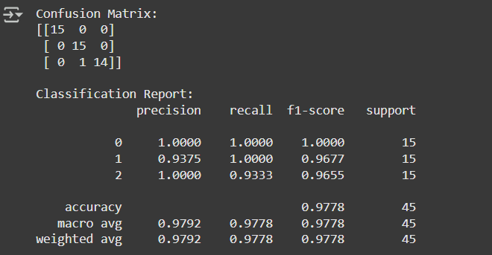
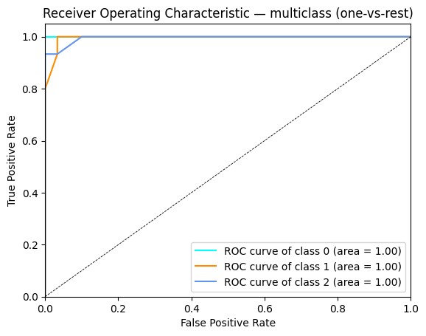
Classification Report:
precision recall f1-score support
setosa 1.00 1.00 1.00 15
versicolor 1.00 0.88 0.93 16
virginica 0.88 1.00 0.93 14
accuracy 0.96 45
macro avg 0.96 0.96 0.96 45
weighted avg 0.96 0.96 0.96 45
ROC Curve Plot with AUC values for each class (one-vs-rest).

